**Experience from the Implementation of a Massive Open Online Course with Google Course Builder**

|  |  |  |
| --- | --- | --- |
|  | Mokter Hossain  Jeff Gray |  |

**ABSTRACT**

This paper presents our experience in designing and delivering an 8-week long Massive Open Online Course (MOOC) with Google Course Builder (GCB) deployed in Google App Engine (GAE) cloud server. The course was offered mainly for the prospective U.S Computer Science Principles teachers to help them be prepared; however, it was open for anyone without any cost or restriction. More than one thousand prospective CS teachers from worldwide participated in this online workshop. Our experience says that there are a number of advantaged features GCB and GAE for designing and delivering MOOCs while there are some challenges and limitations of these services that need to be resolved. The paper depicts some technique how to overcome the challenges in easy or alternative ways that might be helpful for prospective MOOC developers as well as for the GCB and GAE developers for improving these services.

**Categories and Subject Descriptors**

K.3.2 [**Computer and Information Science Education**]: *Computer science education*

**General Terms**

Human Factors

**Keywords**

App Engine, Cloud Computing, Course Builder, MOOC, Open Online Course

1. **INTRODUCTION**

A Massive Open Online Course (MOOC; /muːk/) is an online course that aims to deliver educational services among mass people with free, open, and unlimited participation, accessed over the Web. In addition to traditional web-based course materials such as texts, audios, videos, and problem sets, a MOOC provides interactive user forums that help building a collaborative virtual online community among teachers, students, researchers, and educators. MOOC is a recent development of the online education system that began to emerge in 2012 [5]. According to The New York Times, 2012 became “the year of the MOOC” as several well-financed providers, associated with top universities, emerged, including Coursera, Udacity, and edX [9]. Within this short time many leading universities, for-and non-profit organizations and prominent educator have been working in designing and implementing MOOC. According to a recent statistics on MOOCs Directory [6], 26.5% of US universities; 16.5% of Indian universities; 16.2% of Chinese universities; 3.9% of Canadian, Australian, and UK universities provide MOOCs. Although these rates are not satisfactory, these show a promising raise within this short timeline.

1. **BACKGROUND STUDY**

MOOC is a successful integration of Web 2.0 technology and Cloud computing that provides teaching-learning services in online manner. Web 2.0, which itself a successor of Web 1.0 technology, refers to the second generation of Internet services that provides Internet users many interactive, dynamic, and collaborative services. Web 2.0 allows users to access and customize information; and has made the web design available for users to use, customize, and share freely [8].

Over the past few years, many schools, colleges, universities, as well as profit and not-profit organizations and individual researchers, teachers, and educators have been developing and delivering Web 2.0-assisted online education services. Using the interactive features of Web 1.0 and Web 2.0 technology, Online Course Management Systems (OCMSs) such as Angel, Blackboard Learn, eCollege, WebCT have been developed to provide online and blended teaching-learning systems. These and many others Web 2.0-based OCMSs have recently gained popularity and have been used widely worldwide. However, the major limitations of the OCMS-based courses are that most of thee are costly. Such courses are provided only through the use of supportive tools and technologies that require additional cost, installation, and support in both school and home computers that may have different configurations, operating systems, and security setups [11]. Moreover, students’ and instructors’ access to a WebCT course is limited for a certain time only. Once the course or semester is over students do not have access to the course content. Most notably, designing courses on OCMS requires information technology savvy instructors that are sometimes unavailable or unaffordable by the schools in rural districts or in developing and underdeveloped countries [4].

The problems and challenges of traditional and OCMS-based online courses that limit users to view and access the course content in a certain time or mode, called for the use of MOOC with unlimited and open accessibility. While earlier MOOCs mainly emphasized on open access features, such as social and cultural connectivisms and open licensing of content, newer MOOCs use closed licenses for their course materials but maintain free access for students [1, 2]. As the MOOC facilitates a relatively free and unlimited accessibility it could provide various new dimensions to meet the diversified need of mass people around the globe.

MOOCs allow instructors and designers to manage and control online courses easier than traditional static online teaching-learning systems. The online discussion forums provide the means to decrease many of the limitations of the earlier online systems and increase learners’ problem solving by following a similar method that someone applied or suggested. For instance, in the discussion forums many participants and freelance programmers post their problems, solutions, and suggestions via threaded online discussion forums, blogs, and wikis.

In July 2012, Google inaugurated Course Builder as an experimental project for delivering online courses [7]. It is a kind of extension to WebCT, a online course management tool, that allows instructional designers to create interactive teaching materials for web-based training courses. Google Course Builder (GCB) is an open source online platform that deploys course materials on Google App Engine (GAE), commonly known as App Engine. App Engine is a cloud computing platform, known as Platform as a Service (PaaS), that provides services for developing and hosting web applications in Google-managed data centers [12]. It was first released in April 2008, and came out of preview in September 2011.

Google AE offers automatic scaling for web applications that means as the number of end user requests increases for an application, GAE automatically allocates more resources for the web application to handle its additional demand [10]. App Engine’s infrastructure handles all of the distribution, replication and load balancing of the entire course content and students’ records [3]. Use of GAE services is free up to a certain level of consumed resources, 5 GB for Cloud Storage Standard Storage; 1 GB for Datastore Stored Data; 1GB Outgoing Bandwidth, 28 Frontend Instance Hours; 9 Backend Instance Hours; etc. For additional storage, bandwidth, or instance hours required by the application fees with certain rates are charged to the course developer. More information about Google App Engine Quotas is available at: <https://developers.google.com/appengine/docs/quotas>

The GCB is being developing with an aim to help teachers and educators creating online courses and delivering to any number of students- no matter either ten or a million without any additional effort. Google itself launched several MOOCs, Power Searching with Google V1 in July 2012; followed by Power Searching with Google V2 in September where about 154,000 and 124,000 students registered in these courses, respectively. According to a report on Google Research Blog, the average of students’ satisfaction rate in these MOOCs is more than 4.44 on a 5.0 scale [13]. This implies that Google technologies can help bring education to a global audience. Consequently, Google made the Course Builder technology open and accessible for educators and researchers so that they can develop their own courses open and accessible for mass people [7].

Within a short time, teachers and researchers from many leading universities and educational institutes in the word such as: Stanford University, MIT Media Lab, Indiana University, UC San Diego, Rowan University, Carnegie Mellon University, College of St. Cholastica, Saylor.org, Swiss Federal Institute of Technology in Lausanne (EPFL), LearningByGivingFoundation.org, a group of universities in Spain led by Universia, CRUE, Banco Santander-Universidades, and some other universities have started developing online courses and workshops using the GCB [7].

This project at the University of Alabama is another innovative example of using GCB for the design and delivery of a month long MOOC offered for the prospective high school teachers help them be prepared for teaching Computer Science Principles (CSP) course in their classrooms. The course can be visited at: [https://csp-cs4hs.appspot.com](https://csp-cs4hs.appspot.com/)

This paper starts with an introduction and background study with the MOOC and its predecessor Web 2.0 technology. It briefly discusses the methodology and procedures in conducting the entire research but mainly focuses on the problems faced during the development and administrating phases and actions taken to resolve the problems. Finally, it ends up with some recommendations for the prospective teachers how to develop such a course more efficiently as well as for the GCB and GAE developer teams for further improvement of these technology followed by a brief conclusion.

### PROCEDURE

The aim of this study was to design and deliver a MOOC for preparing the Computer Science Principles teachers with GCB on GAE cloud server. Before implementing the final course, we deployed a test course to play with our desire features on it. Permission was sought from our university Institutional Review Board (IRB) for conducting the pre- and post-surveys.

**3.1 Research Questions**

This paper deals to answer the following research questions:

**Research question 1:** What are the advantages of using GCB in designing and implementing a MOOC over the traditional online course management system?

**Research question 2:** Are there any requirement or challenge for the mass people in joining and completing an open online course on GCB?

**Research question 3:** What are the requirements for the teachers and researchers in designing, implementing a MOOC on GCB?

**Research question 4:** What are the main challenges in designing and administrating a MOOC; and how to overcome such challenges?

1. **FINDINGS AND DISCUSSION**

**4.1 Advantages of Using GCB**

There are a number of advanced features GCB for designing and implementing MOOCs over the traditional OCMSs. For instance, GCB provides a great opportunity for teachers and educators for designing and implementing a MOOC without having enough programming background. Use of GCB is relatively cost effective than the traditional online course management tools such as Angel, Blackboard Learn, WebCT, and/or many Web-based applications. GCB provides an open, free, and 24/7 accessibility for the participants. The GCB provided MOOC is too open that even GCB does not permit the course developer or the instructor to restrict a person from registering or enrolling a class. Even if a participant un-enroll himself from a class he can come back to rejoin in the course anytime he wishes with the same email address. Unlike blogs and many other Web 2.0 tools, GCB is more easier and flexible in using formatted texts, links, images, videos, activities, Google Docs, and many other static and dynamic features in a lesson. Adding and editing a New Course, Unit, Lesson, Activity, Assessment and/or link is easy enough. A GCB course can include any number of Units; any number of lessons and activities can be included in a Unit. These mean that GCB should be appropriate for designing and implementing any kind of courses that may have different kind of lessons, activities, and units. Thus, GCB could be used for designing and delivering any kind of online or blended class.

**4.2 Challenges for the Participants**

It seems to us that in order to join in and complete an open online course a person does not need to have any kind of programming knowledge unless that is requires for the course itself. However, the person must have basic computing expertise and a Gmail address or at least a Google credential email address for registering in an open online course on GCB.

At the time of writing this paper, there were 1010 participants enrolled in this class. In order to know the demographic information of the participants we included an anonymous Pre-survey in the course. After registering into the class, participants were asked to complete the Pre-survey. Five hundred eighty eight of them completed the Pre-survey. These were form all of the U.S. states excepts Delaware, South Dakota, Vermont, and Wyoming; and from some other countries including, Australia, Bangladesh, Canada, China, India, Spain, France, Germany, Nigeria, Paraguay, Singapore, and South Korea. Among these about 73% were public high school teachers, about 20% were private school teachers, and the remaining were charter school teachers and after school programs.

|  |  |  |  |  |  |  |  |
| --- | --- | --- | --- | --- | --- | --- | --- |
| **Table – 1. Participants’ teaching level by school type cross tabulation** | | | | | | | |
| School Type →  -------------------  Teaching Level ↓ | | Public School | Private School | Charter School | After school program | null | Total |
| Elementary | 0 | 4 | 3 | 0 | 1 | 0 | **8**  **(1.4%)** |
| Middle School | 0 | 33 | 18 | 0 | 3 | 2 | **56**  **(9.5%)** |
| High School | 0 | 341 | 77 | 12 | 0 | 3 | **433**  **(73.6%)** |
| Post-Secondary | 1 | 29 | 9 | 1 | 0 | 0 | **40**  **(6.8%)** |
| Currently not Teaching | 0 | 19 | 6 | 1 | 4 | 11 | **41**  **(7%)** |
| null | 0 | 4 | 2 | 0 | 0 | 4 | **10**  **(1.7%)** |
| Total | 1 | **430**  **(73.1%)** | **115**  **(19.6%)** | **14**  **(2.4%)** | **8**  **(1.4%)** | **20**  **(3.4%)** | 588 |

Among the high school teachers more than 37.4% were either currently teaching at least a CSP course. Moreover, about 41.6% were not sure but might be teaching a CSP course in the near future. Among the public and private school teachers these rates were about 36.8% and 39.3%; and 38.3% and 44.4%, respectively. For more detail, please see Table -1 and Table-2.

Due to several requests by some participants the duration of this online course has been extended for a few more weeks. At the time of writing this paper, the course was still running, thus, we are not able to present more data about the participants and their perceptions about it. In the course schedule, there is another post-survey yet to be conducted. After conducting and analyzing that data hope we will be able to present our further experience in the conference presentation.

|  |  |  |  |  |  |  |
| --- | --- | --- | --- | --- | --- | --- |
| **Table – 2. Participants’ teaching level and school type by Plan of Teaching a CSP course cross tabulation** | | | | | | |
|  |  | Yes | No | Not Sure | null | Total |
| Teaching Level | Elementary | 2 | 1 | 5 | 0 | 8 |
| Middle School | 25 | 10 | 21 | 0 | 56 |
| High School | 162  (37.4%) | 91  (21.1%) | 180  (41.6%) | 0 | 433  (100%) |
| Post-Secondary | 12 | 13 | 14 | 1 | 40 |
| Currently not Teaching | 4 | 22 | 15 | 0 | 41 |
| null | 3 | 3 | 3 | 1 | 10 |
| **Total** | | **208** | **140** | **238** | **2** | **588** |
|  | |  |  |  |  |  |
| School Type | Public School | 158  (36.8%) | 102  (23.8%) | 169  (39.3%) | 1 | 430  (100%) |
| Private School | 44  (38.3%) | 20  (17.4%) | 51  (44.4%) | 0 | 115  (100%) |
| Charter School | 4 | 2 | 8 | 0 | 14 |
| After school program | 1 | 3 | 4 | 0 | 8 |
| null | 1 | 12 | 6 | 1 | 20 |
| **Total** | | **208** | **140** | **238** | **2** | **588** |

**4.3 Requirements for the MOOC Developers**

According to our initial experience while implementing this open online course we have realized that an interesting teacher or researcher should have some sort of programming knowledge in designing, implementing an open online course on GCB? He also must have a Gmail address or at least a Google credential email address for creating an App on the Google App Engine.

**4.4 Challenges for the Developers**

While designing and delivering this MOOC on GCB we noticed some issues and limitations both in the GCB and GAE applications. In this section, we will briefly cover some of these. *First*, the Course Builder Get Started wiki page <http://code.google.com/p/course-builder/wiki/GetStarted> discusses the basic need and steps for getting started with Course Builder. The first page (title: Download the Software) describes how to download Python, Google App Engine, and Course Builder. The second page (title: Run Course Builder) describes how to run Course Builder for the first time. The third page (title: Explore Course Builder) describes how participating students see when they take the course. Finally, the fourth page (title: Deploy to Google App Engine) describes how to deploy Course Builder to Google App Engine so we can start building our new course. In this page there is a link (<http://www.youtube.com/watch?v=OtVd1komyGY&list=PLbTy14-ZMIDJGS1XLdYj3Nzrhfd6EDWJC>) of three short YouTube videos describing all of the above steps - from the downloading to the creating of a new course. In the third video, it shows how to deploy the Course Builder to Google App Engine through using the appcfg.py using command line instructions. However, it can be done more efficiently by selecting the desired App and then clicking on the Deploy button.

*Second*, the Course has some kind of Color incompatibility to the different browsers. For instance, we were trying to replace the Course Builder’s Navigation Bar’s default gray color by our favorite Crimson color (#990000). After editing the corresponding CSS program codes, we did not found that effecting in one of our desktop computers. Then we were worried about that and spent a lot of time thinking about our mistake. We did not notice that was effective on our computer’s Google Chrome browser but not on the Internet Explorer and Firefox browsers. Later we noticed that some of the gradient styles defined in the Course Builder CSS are not supportive to all browsers.

*Third,* the GAE has easy accessibility for Backup of selected entries; restore the backed up entries to the same or another App; and delete the selected entries. But it has no such option to download the any kind of entries. This might be tough part for many MOOC course developers during their initial phases.

This seems to us one of the notable limitations of Google App Engine. Even some of the instructions stated and recommended in the Course Builder and App Engine wiki and documentation pages do not work properly. As stated in this wiki page:

[https://code.google.com/p/course-builder/ wiki/ExportCourseData](https://code.google.com/p/course-builder/%20wiki/ExportCourseData)

In order to download Course Data from the App Engine cloud server the Course Builder recommends to configure the file paths by creating a python program file named *gcbpaths.py,* save that into the \tools\etl folder, and run a command line statement with the following format:

python tools/etl/gcbpaths.py download course <course_url_prefix> <app_name> <app_server_name> --archive_path <archive_path>

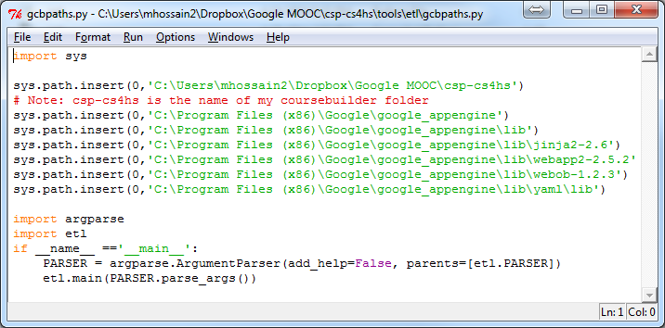

**Figure 1. Customized gcbpaths.py file**

Accordingly, we created the above *gcbpaths*.*py* file and saved in the …\csp-cs4hs\tools\etl folder. It is noted that we renamed the coursebuilder folder as *csp-cs4hs* which was our app_name. Then in order to download the course data, we tried to execute the following command but did not work and gave an authentication error as shown below:

CD C:\Users\mhossain2\Dropbox\Google MOOC\csp-cs4hs

python tools/etl/gcbpaths.py download course /csp4hs csp-cs4hs csp-cs4hs.appspot.com --archive_path ./csp4hs.zip

raise EnvironmentAuthenticationError

tools.etl.remote.EnvironmentAuthenticationError

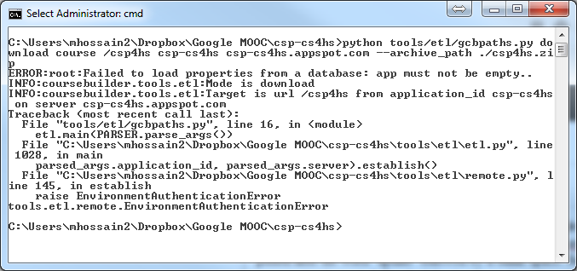

**Figure 2. Error message found while trying to download course content using gcbpaths.py**

Similarly, in order to download Student record from the app’ data stored in App Engine could server, according to their format we tried with the following statement that should download our student information- but that did not work for us either.

python tools/etl/gcbpaths.py download datastore /csp4hs csp4hs csp-cs4hs.appspot.com --archive_path ./csp4hs.zip --datastore_types Student

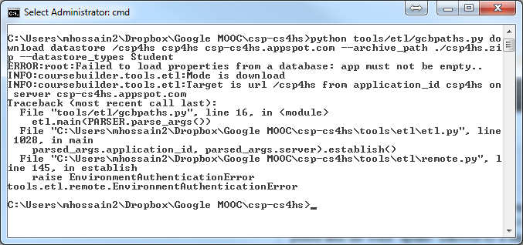

**Figure 3. Error message found while trying to download student property using gcbpaths.py**

Finally, after a Google Hangout conference with a Course Builder specialist in Google, we came to know that the instructions stated for downloading course and students’ information from the App Engine’s cloud server are compatible with Mac and Linux operating systems and do not work in Windows operating systems. But the Course Builder documentation pages do not have any explicit instruction regarding this crucial issue.

Even, we did not find any solution in the Course Builder forum page. After doing some Google search with related issue, we found a post similar to this issue. We then contacted the person who originally posted this issue requesting for her solution. In the reply e-mail she told us told that the above process does not work; thus, asked us for using an alternative way as stated in the following page:

<https://developers.google.com/appengine/docs/python/tools/uploadingdata#Python_Using_automatic_configuration>

Following the instruction stated in the above page, we tried with the following commands:

CD C:\Program Files (x86)\Google\google_appengine

appcfg.py create_bulkloader_config --filename=bulkloader.yaml --url=http://csp-cs4hs.appspot.com/_ah/remote_api

This was according to their recommended format:

appcfg.py create_bulkloader_config --filename=bulkloader.yaml --url=http://<your_app_url> .appspot.com/_ah/remote_api

It is noted that this appcfg.py file is found in the *C:\Program Files (x86)\Google\google_appengine* directory for our PC with 64-bit Windows 7 OS. For a 32-bit version of Windows 7 it should be found in the *C:\Program Files\Google\google_appengine* directory.

But, we found the following error message on our Win8 PC. We found the same error message while trying it in another desktop with Windows 7.

IOError: [Errno 13] Permission denied: 'C:\\Program Files (x86)\\Google\\google_appengine\\bulkloader-log-20140505.012856'

However, fortunately, we found it worked well on our another PC with Windows 7 using the same command as above without having any error message.

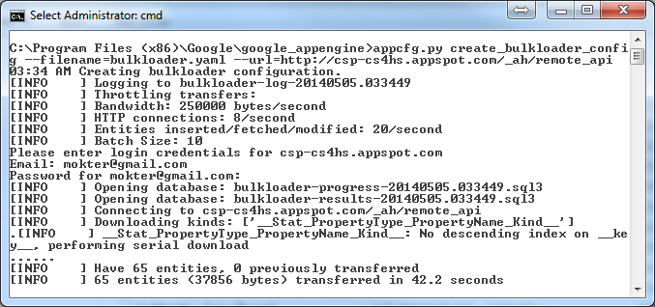

**Figure 4. Successful download of bulkloader.yaml using appcfg.py in another desktop Windows 7**

The above command creates an auto generated *bulkloader.yaml* file that comes up without any connector type. So, we have had to edit the following line:

connector: # TODO: Choose a connector here: csv, simplexml, etc...

using our desired connector type “csv” as shown below.

connector: csv # TODO: Choose a connector here: csv, simplexml, etc...

There were about 15 places where it was asked TODO. The connector_options were kept unchanged. Additionally, there were another TODO: as follows:

import_transform: transform.create_foreign_key('TODO: fill in Kind name')

Where it was asked “TODO: fill in Kind name”. We edited it as follows:

import_transform: transform.create_foreign_key('Reviewee')

Then we were able to download the Student data from the Google App Engine.

python appcfg.py download_data --config_file=bulkloader.yaml --filename=student.csv --kind=Student --url=http://csp-cs4hs.appspot.com/_ah/remote_api --namespace=ns_CSP4HS

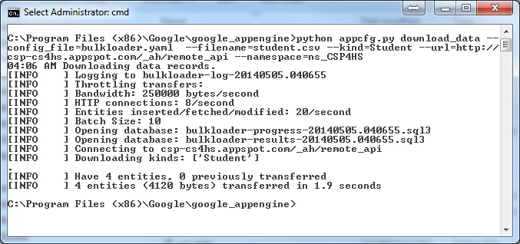

**Figure 5. Successful dowload of student.csv data using the appcfg.py file with customized bulkloader.yaml**

The processes of downloading student data from the GAE clound data storage took a lot of time for us because the same process did not work on our another computer where we usually did most of the activities of this research. Later we came to know that these commands should be executed on Mac and/or Linux OS. But the Course Builder documentation page, wiki, and forum have not mentioned this issues explicitly. Overall, this is a tough process has many possibility of doing unexpected mistakes for the course developers. Thus, having a direct download option inside the App Engine is highly desired.

1. **IMPLICATIONS OF THE STUDY**

The results of this study have possible implications for researchers, educators, computer scientists, teachers, teacher educators, curriculum developers, instruction designers, and software engineers regarding the use of MOOCs for teaching, learning, and planning purposes. A few of these possibilities are as follows. The findings of this study might provide a great opportunity for teachers and educators who do not have enough programming background but wish to design and implement such an open online class for their students and fellow researchers. The Google GCB and GAE developer teams can consider the difficulties and limitations in their services that we faced and mentioned in this paper. Resolving these difficulties and limitations should make their products more convenient and useful to the prospective teachers, and researchers who would opt to use upgraded versions of these products.

1. **CONCLUSIONS**

MOOC is an impressive and emerging online distance education service that has been gaining increased popularity by the prominent educators, researchers, and universities worldwide. The GCB in accordance with the GAE provide an open, free, and 24/7 accessibility for the participants. There are lot of advantages of using GCB and GAE for designing and delivering a MOOC while there a some minor difficulties and limitations of using these services. It seems that the Course Builder and App Engine are more compatible with the Mac and Linux environment than the Windows. Even some of the instructions stated and recommended in the GCB and GAE documentation and wiki pages do not work properly. This paper noted a few of such issues and demonstrated alternative solutions. Findings of this study will help prospective educators and researchers in designing and implementing such a MOOC; and well as the GCB and GAE developer teams to improve these resources. Hope, as more educators will be designing more MOOCs using GCB and GAE, these will come up with more interactive and additional features.

**ACKNOWLEDGEMENT**

This paper is based upon work supported by the National Science Foundation under Grant No. CE21 (CNS-1240944).

1. **REFERENCES**

[1] Cheverie, Joan. “MOOCs an Intellectual Property: Ownership and Use Rights”. Retrieved 18 April 2013, from http://www.educause.edu/blogs/cheverij/moocs-and-intellectual-property-ownership-and-use-rights

[2] David F Carr (20 August 2013). “Udacity hedges on open licensing for MOOCs”. *Information Week*. Retrieved 21 August 2013.

[3] Doukas, C., & Maglogiannis, I. (2011, November). “Managing wearable sensor data through cloud computing”. In *Cloud Computing Technology and Science (CloudCom), 2011 IEEE Third International Conference on* (pp. 440-445). IEEE.

[4] **Hossain, M. M.** & Quinn, R. J. (2012, March). “Prospective Use of Web 2.0 Technologies in Promoting Mathematics Education in the United States”. In Proceedings of Society for Information Technology & Teacher Education International Conference, 2012 (1). 3637-3642. Chesapeake, VA: AACE

[5] Lewin, Tamar (20 February 2013). “Universities Abroad Join Partnerships on the Web”. *New York Times*. Retrieved March 16, 2014.

[6] **MOOCs Directory. (2014). “Higher Education MOOCs”**. Retrieved May 5, 2014 from, http://www.moocs.co/ Higher_Education_MOOCs.html

[7] Norvig, P. (2012). “Helping the World to Teach”. Retrieved March 14, 2014, from http://googleresearch.blogspot.com/ 2012/09/helping-world-to-teach.html

[8] O'Reilly, T. (2009). “The war for the Web”. *IT Conversations.* Retrieved October 30, 2010, from http://itc.conversationsnetwork.org/ shows/detail4317.html

[9] Pappano, Laura. “The Year of the MOOC”. The New York Times. Retrieved 18 April 2014, from http://www.nytimes.com/2012/11/04/education/edlife/massive-open-online-courses-are-multiplying-at-a-rapid-pace.html

[10] Sanderson, D. (2009). “Programming Google App Engine: Build and Run Scalable Web Apps on Google's Infrastructure”. O'Reilly Media, Inc.

[11] Thomas, D. A., & Li, Q. (2008). “From Web 2.0 to Teacher 2.0”. *Computers in the Schools, 25*(3-4), 199-210.

[12] Wang, Y., Wang, S., & Zhou, D. (2009). “Retrieving and indexing spatial data in the cloud computing environment”. In *Cloud Computing* (pp. 322-331). Springer Berlin Heidelberg.

[13] Wilkowski, Julia. (2013). “A Comparison of Five Google Online Courses”. Retrieved on May 1, 2014 from http://googleresearch.blogspot.com/2013/09/a-comparison-of-five-google-online.html